
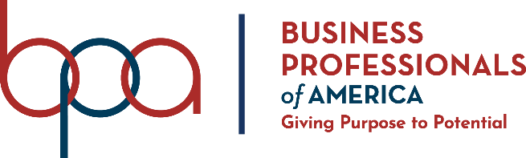
Human Resource Management
(535)

NATIONAL 2020

PRELIMINARY

Presentation Points (140 points)

Specification Points (20 points)

TOTAL POINTS (160 points)

Failure to adhere to any of the following rules will result in disqualification:
- Contestant must hand in this test booklet and all printouts. Failure to do so will result in disqualification.
- No equipment, supplies, or materials other than those specified for this event are allowed in the testing area. No previous BPA tests and/or sample tests or facsimile (handwritten, photocopied, or keyed) are allowed in the testing area.
- Electronic devices will be monitored according to ACT standards.

No more than ten (20) minutes preparation
No less than three (3) and no more than five (5) minutes oral presentation
No more than three (3) minutes judges’ questions

Property of Business Professionals of America.
May be reproduced only for use in the Business Professionals of America
Workplace Skills Assessment Program competition.

Description
Assess interpretation of personnel policies and knowledge of human resource management.

National Preliminary Scenario:
Dalton Miller was the lucky candidate selected by Professional Business Associates for an internship as a junior marketing assistant. He has just completed his third year of college and is determined to land a career at Google upon graduation. Although Dalton does quality work and continues to show promise as a creative marketer, he doesn’t like to conform to company standards. His clothing looks faded and worn, his shirts reveal a small tattoo on his upper arm and shoulder, and his hair is not always clean. In addition, he “needs” to have his phone with him at all times to receive notifications and keep his friends updated on his day. He leaves the office for lunch to revive his creativity but often returns late due to the long walk to the deli.

Up until now, Dalton has worked his way through college by taking on simple advertising jobs for local small businesses. He has continued to work for some of his existing clients so he doesn’t lose their business. Aside from the lack of professionalism, his coworkers see him as “quirky” and enjoy his personality.

As a Human Resources Manager, how would you handle this situation? In your solution, include recommendations for Dalton. Use your Human Resources Manual as a guide.

A contestant will be DISQUALIFIED for violations of the Copyright and Fair Use Guidelines.

Contestants who do not submit an entry that follows this topic will be disqualified.

Solution—Topics may be found in the Human Resources Manual
- See What Professional Business Associates Expects From You – pages 8-9
- See Unacceptable Activities – pages 12-14
  - #1
  - #12
- See Disciplinary Actions – page 14
- See Dress Code – pages 17-18
  - #1
  - #2
  - #4
  - #6
- See Social Media Policy – pages 18-19
- See Meal Periods – page 20

